CSE110 Quiz 1 07/10/2010

ID __________________ Name __ Ejaz

Draw the flowchart of a program that calculates the sum of first 9 terms of the following series 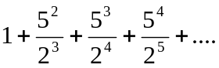

Hint: If you multiply, power increases by one.

